Lab Assignment-2

ECSE373L: Cloud Infrastructure and Services

**Name:** Tanvi Penumudy

**Enroll no**: E18CSE187

**Batch:** EB02

**My AWS Academy Console Name:** voclabs/user1199245=TP6145@bennett.edu.in @ 5280-5451-2476

**Lab Activities (AWS Academy Module 5 Lab 2):**

* **Task 1:** Create your VPC
* **Task 2:** Create Additional Subnets
* **Task 3:** Create a VPC Security Group
* **Task 4:** Launch a Web Server Instance

**Implementation Screenshots (Step-by-Step):**

**Task 1:** Create your VPC

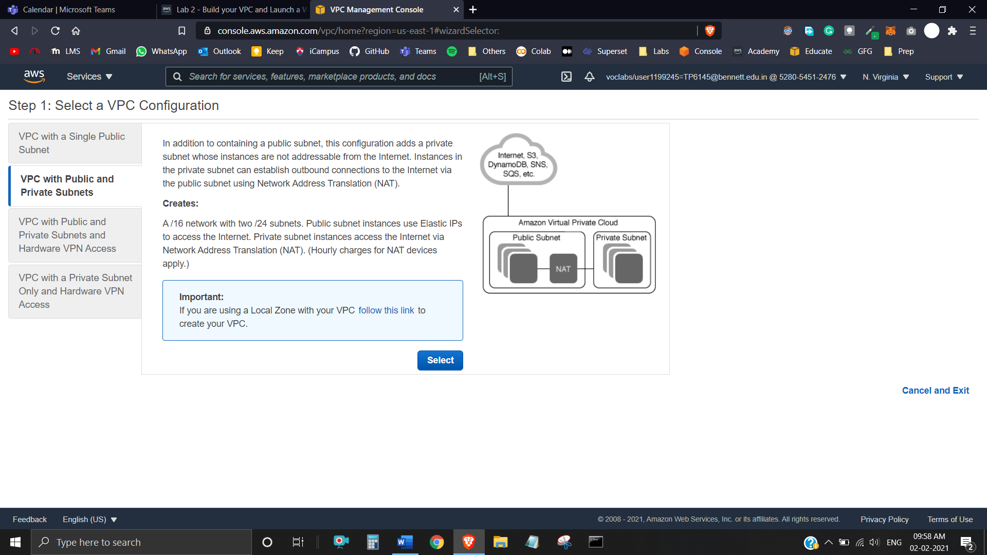

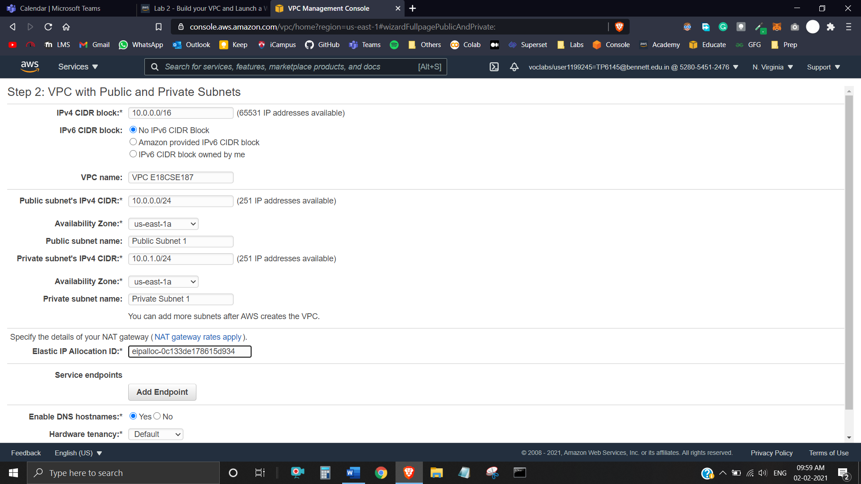

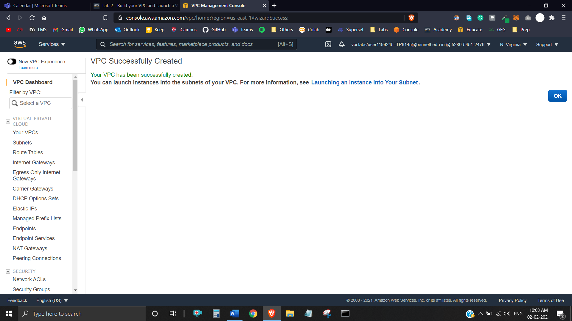

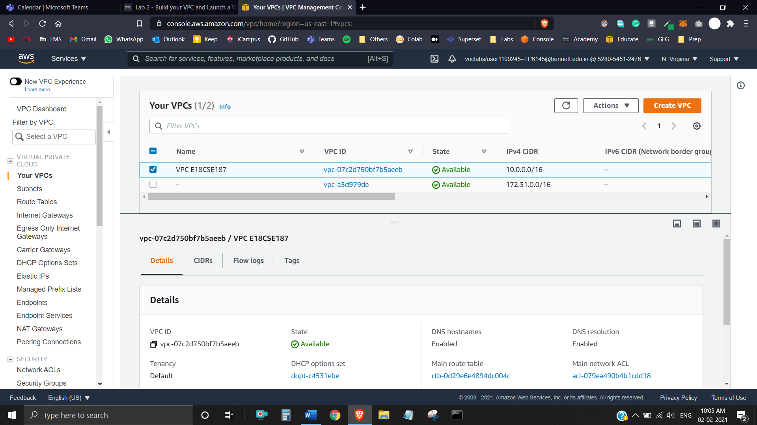

The wizard has provisioned a VPC with a public subnet and a private subnet in the same Availability Zone, together with route tables for each subnet:

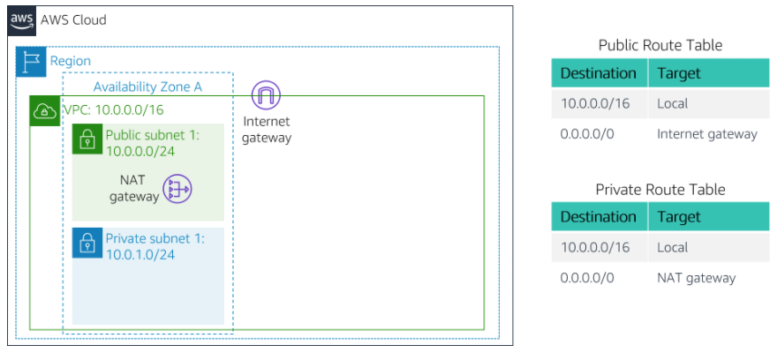

The Public Subnet has a CIDR of **10.0.0.0/24**, which means that it contains all IP addresses starting with **10.0.0.x**.

The Private Subnet has a CIDR of **10.0.1.0/24**, which means that it contains all IP addresses starting with **10.0.1.x**.

**Task 2:** Create Additional Subnets

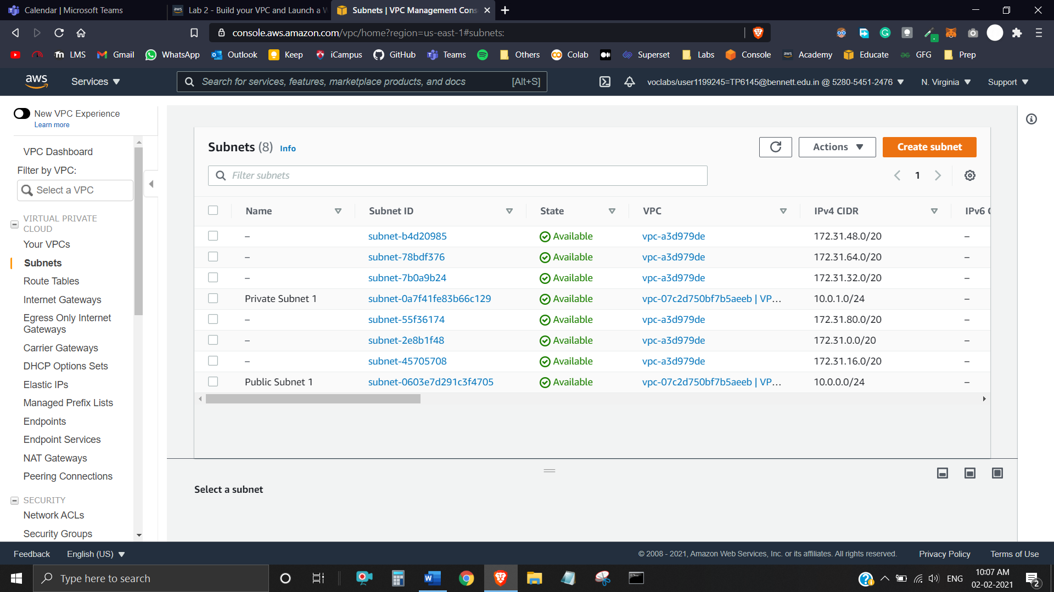

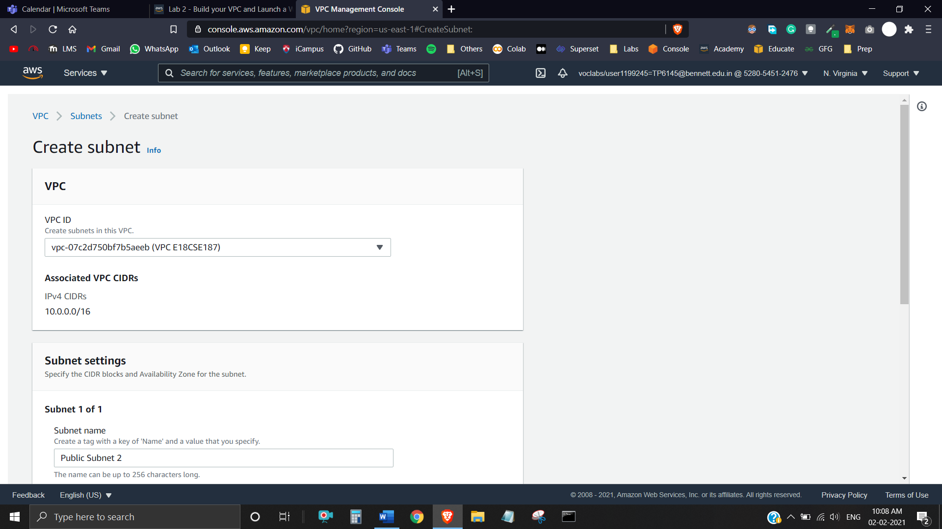

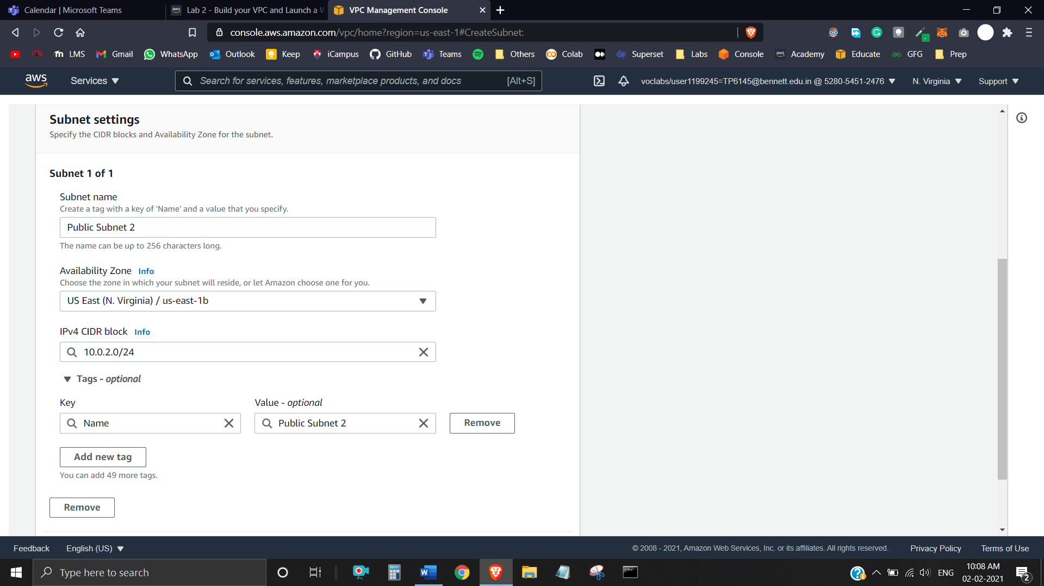

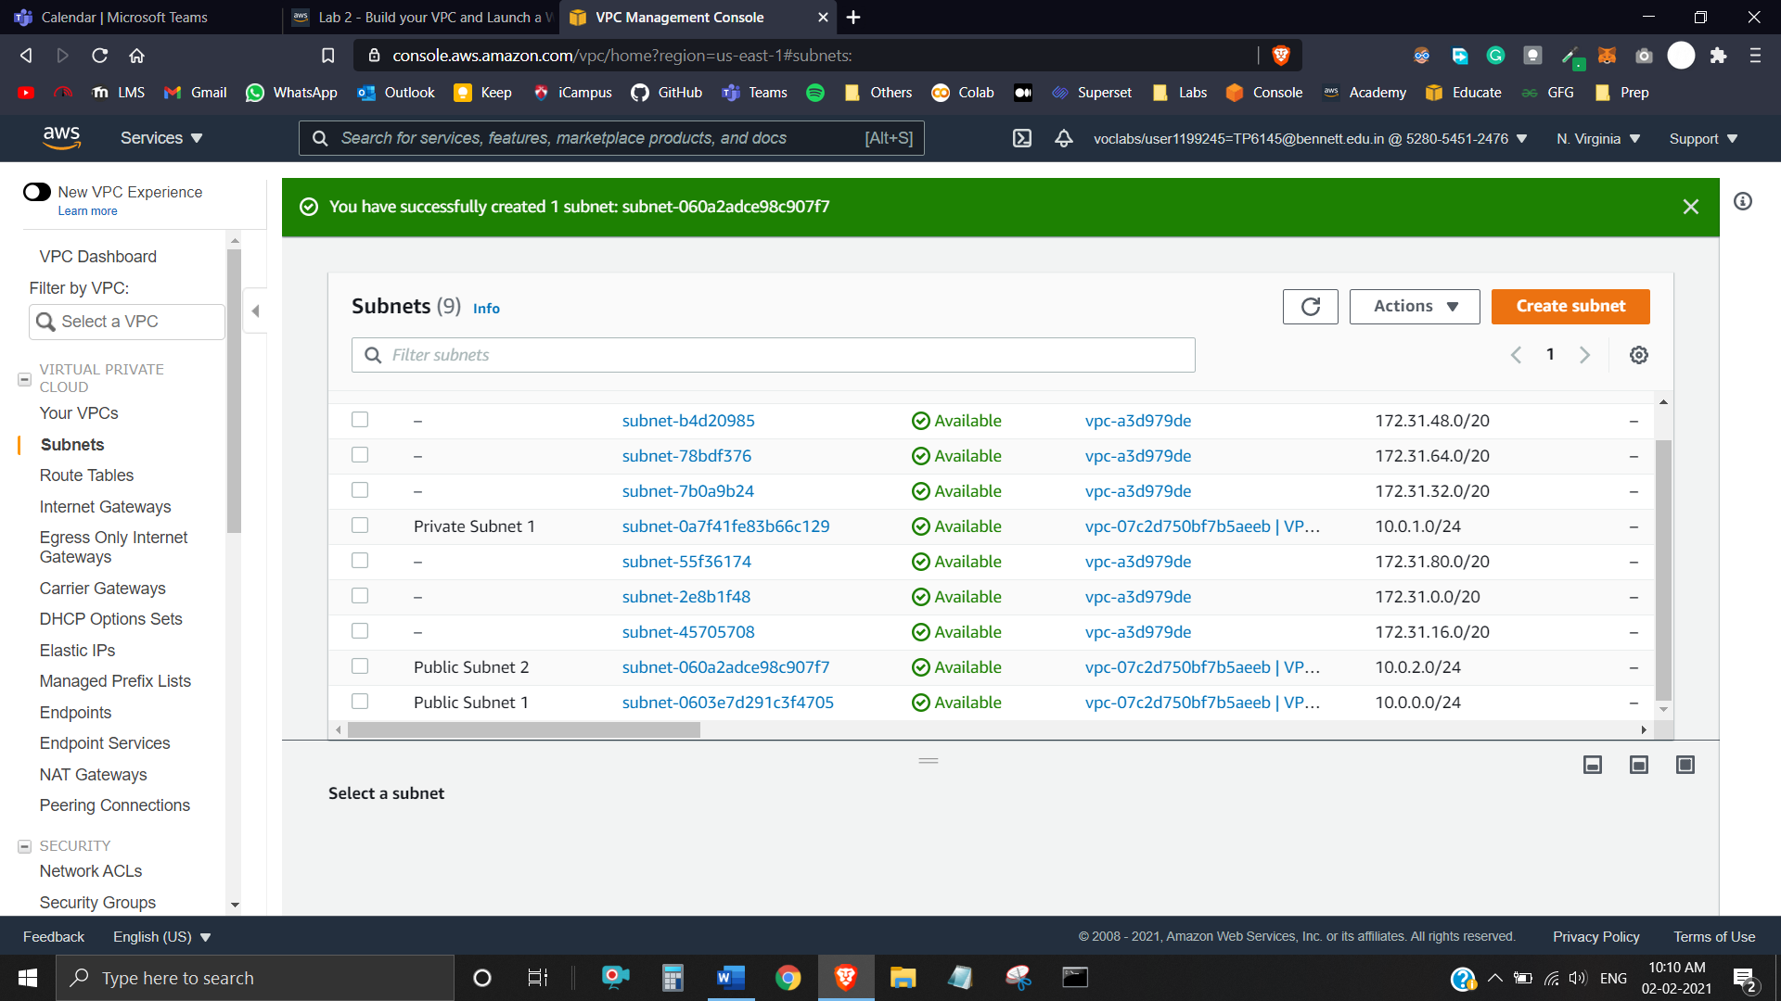

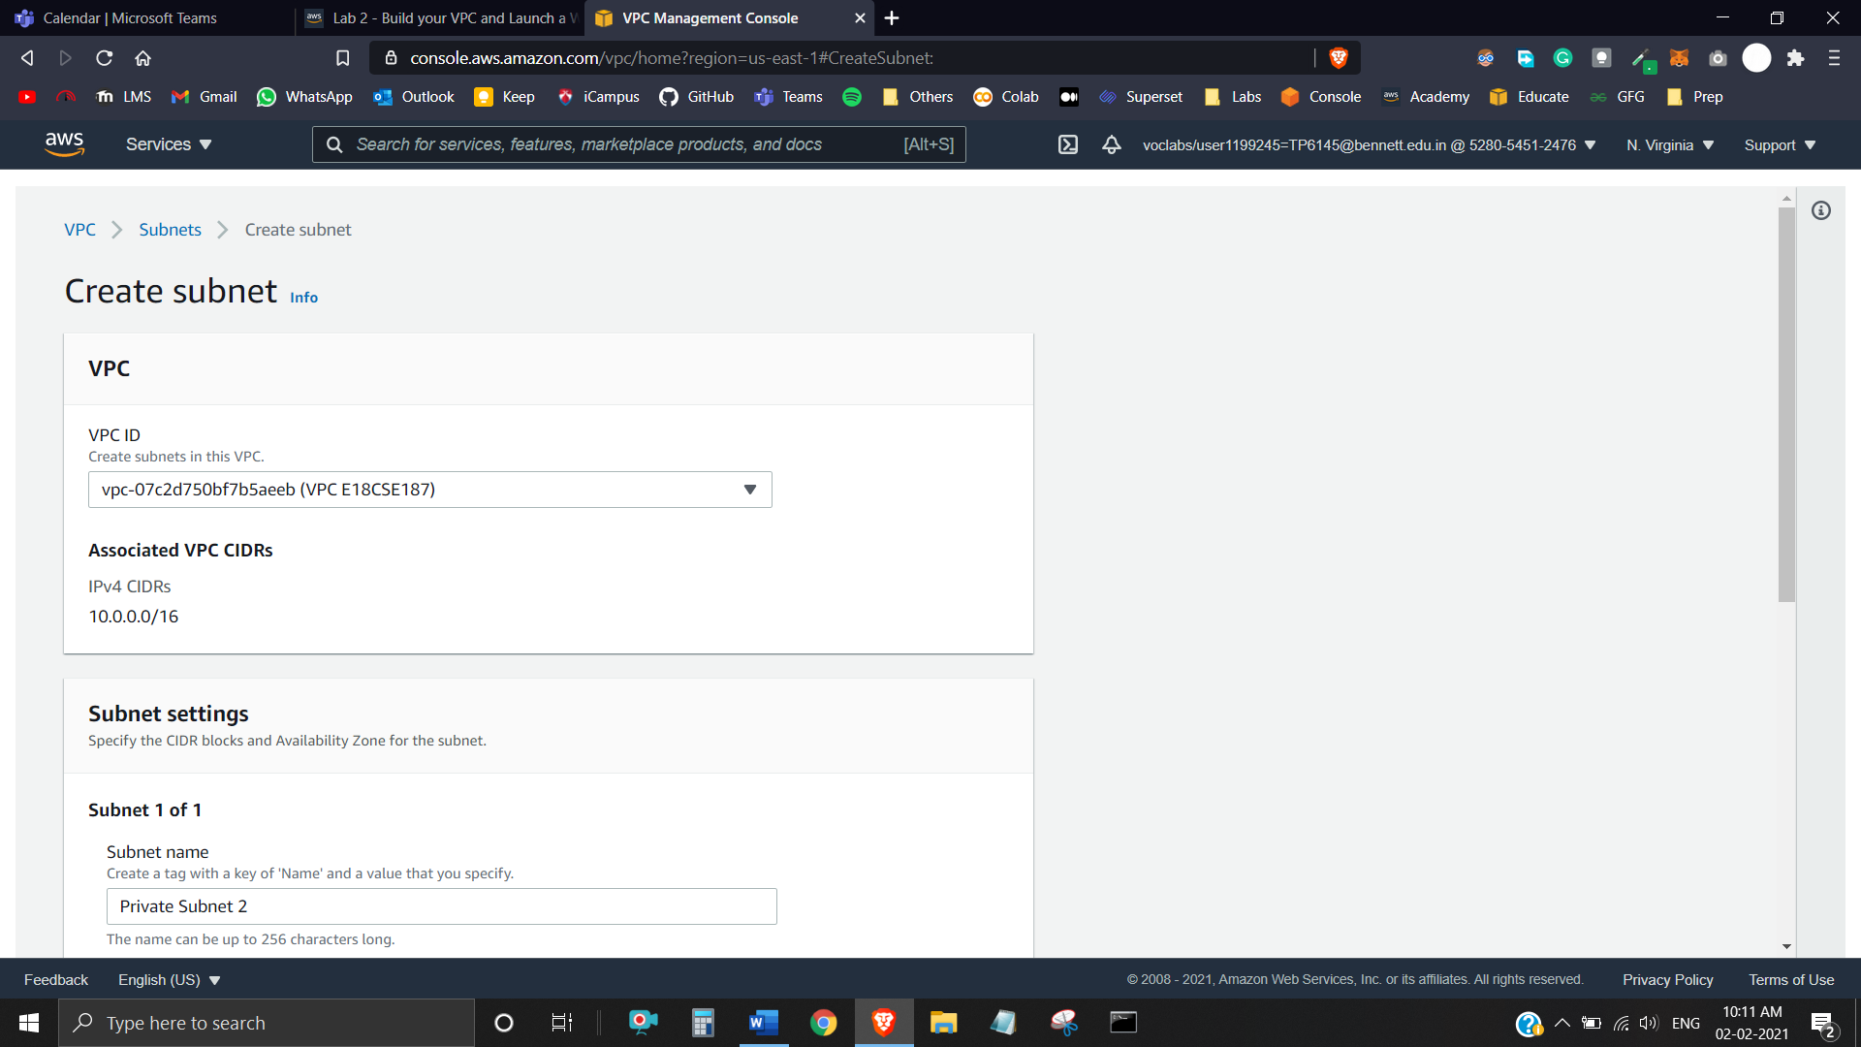

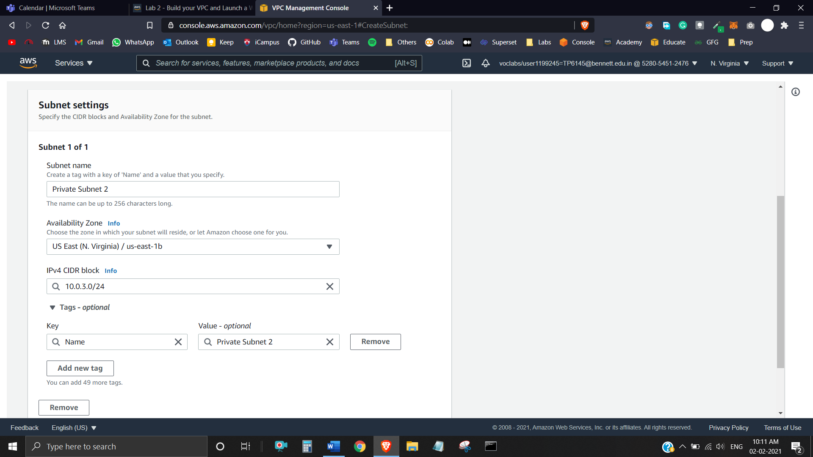

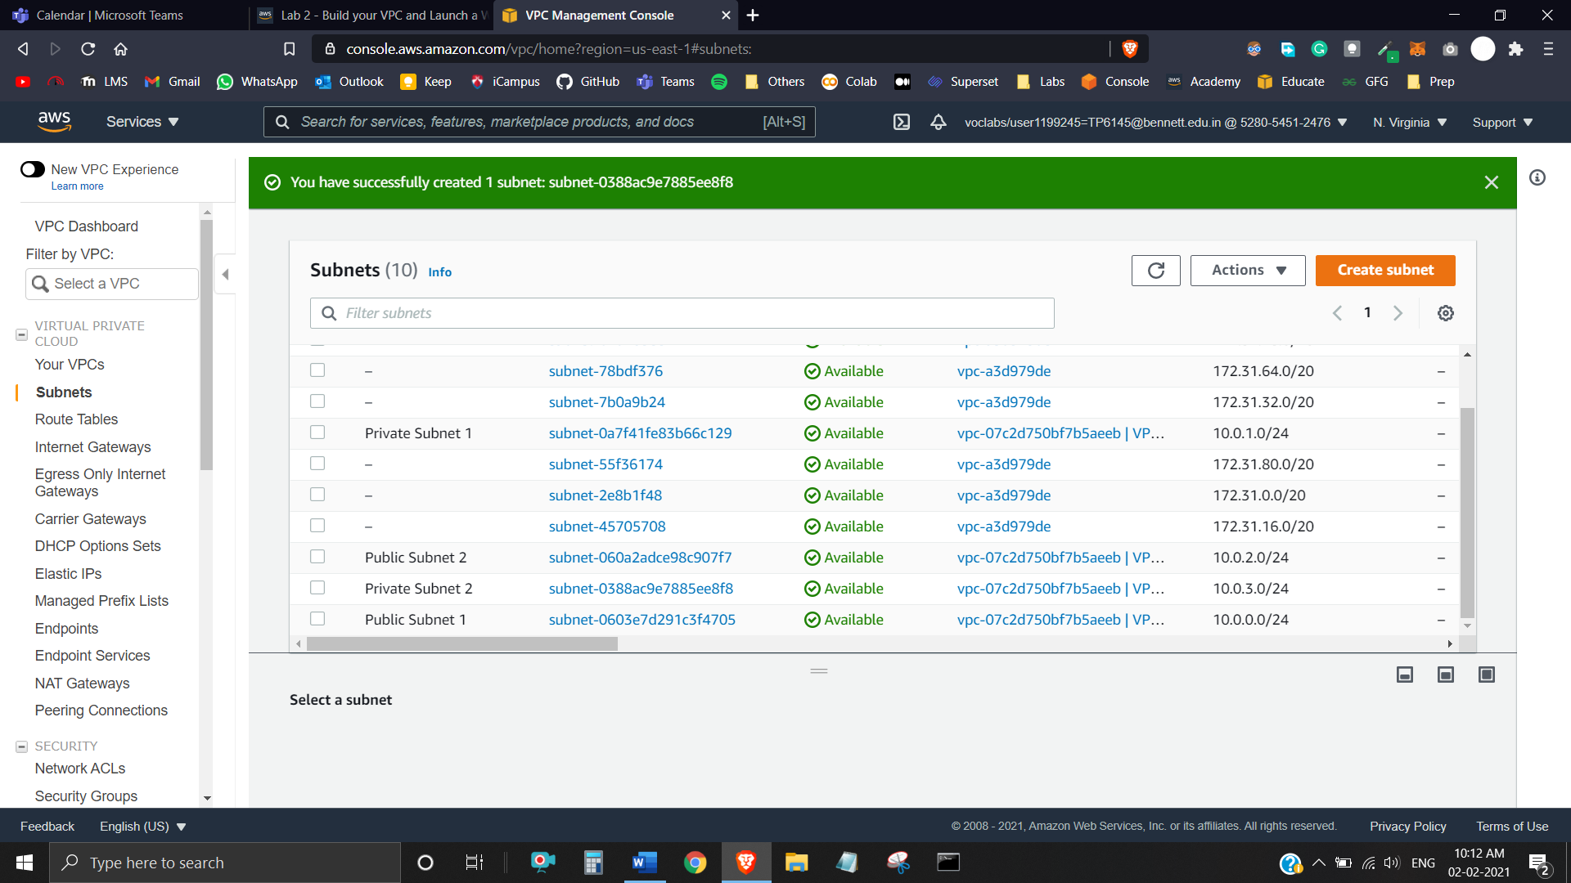

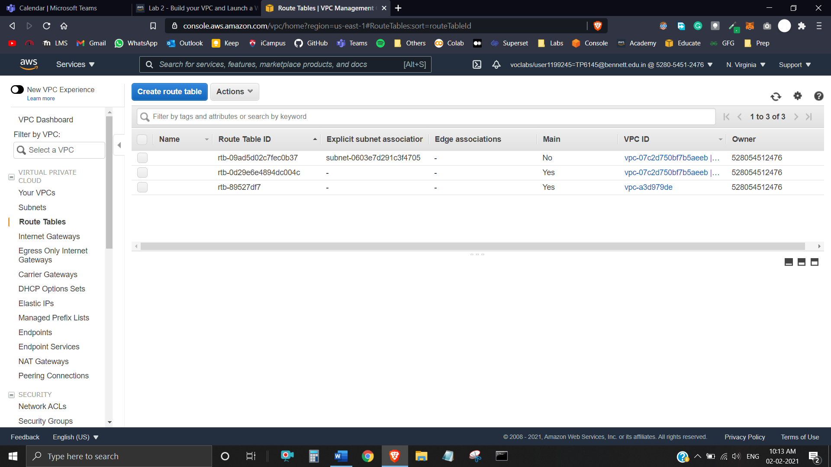

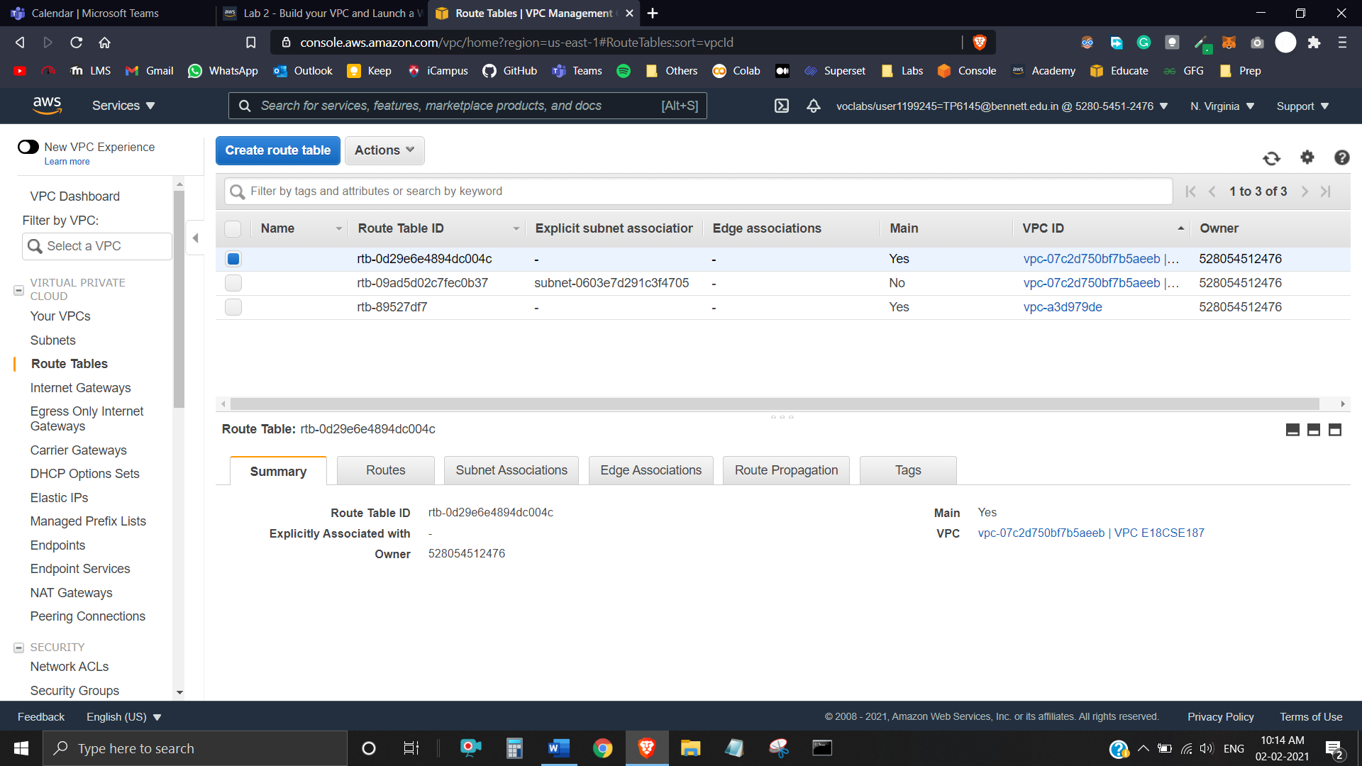

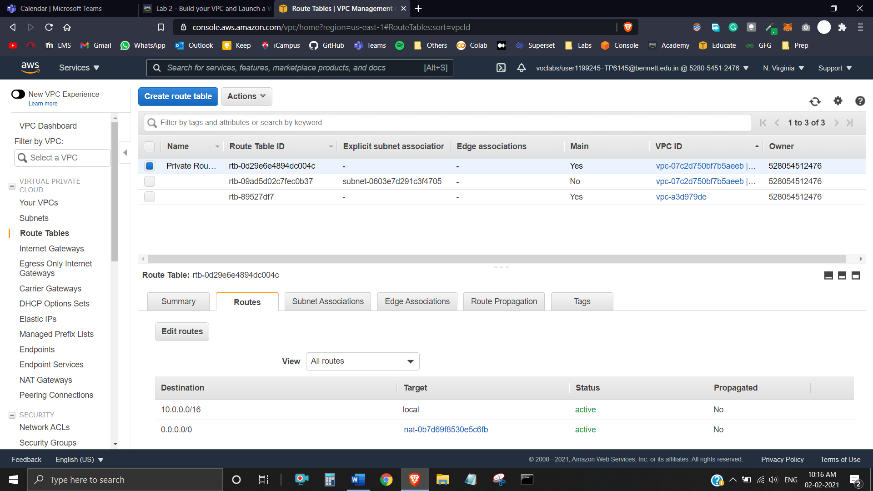

Note that **Destination 0.0.0.0/0** is set to **Target nat-xxxxxxxx**. This means that traffic destined for the internet (0.0.0.0/0) will be sent to the NAT Gateway. The NAT Gateway will then forward the traffic to the internet.

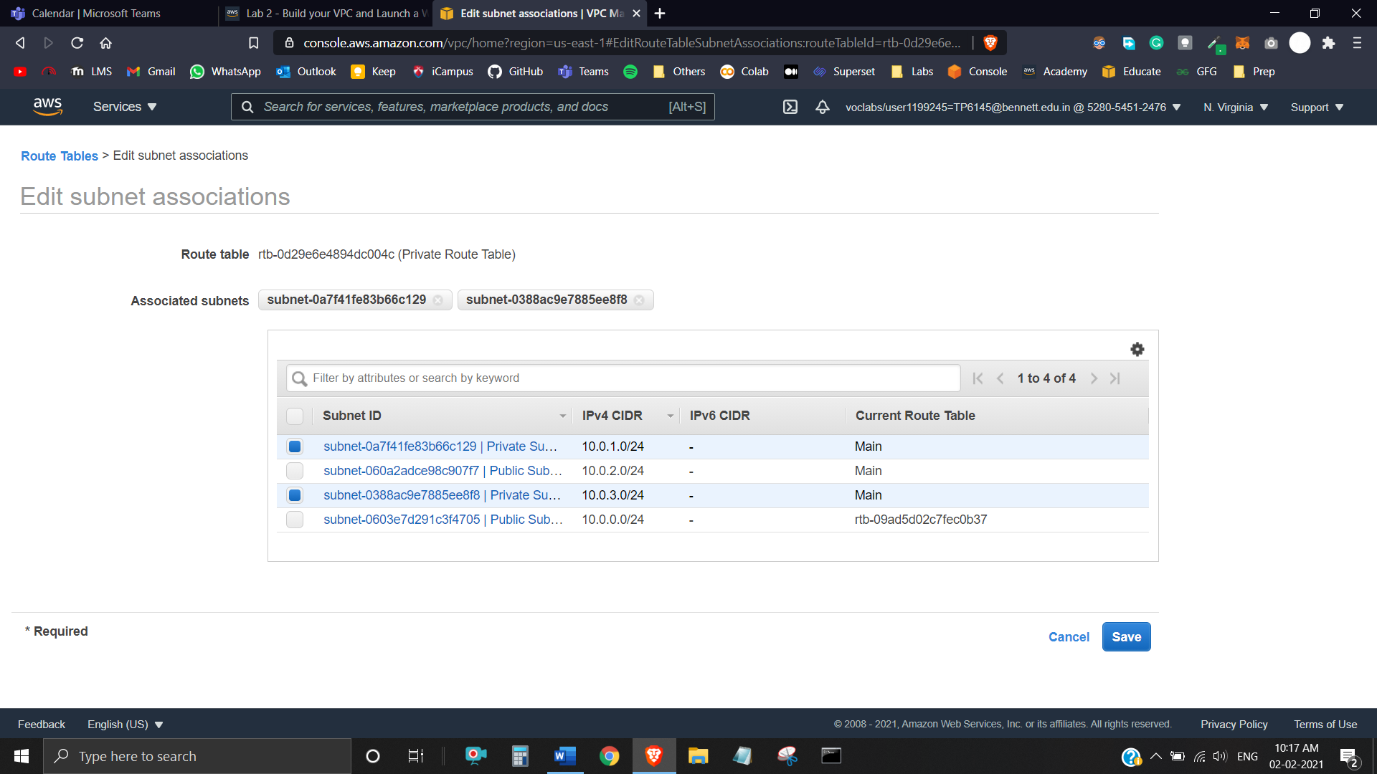

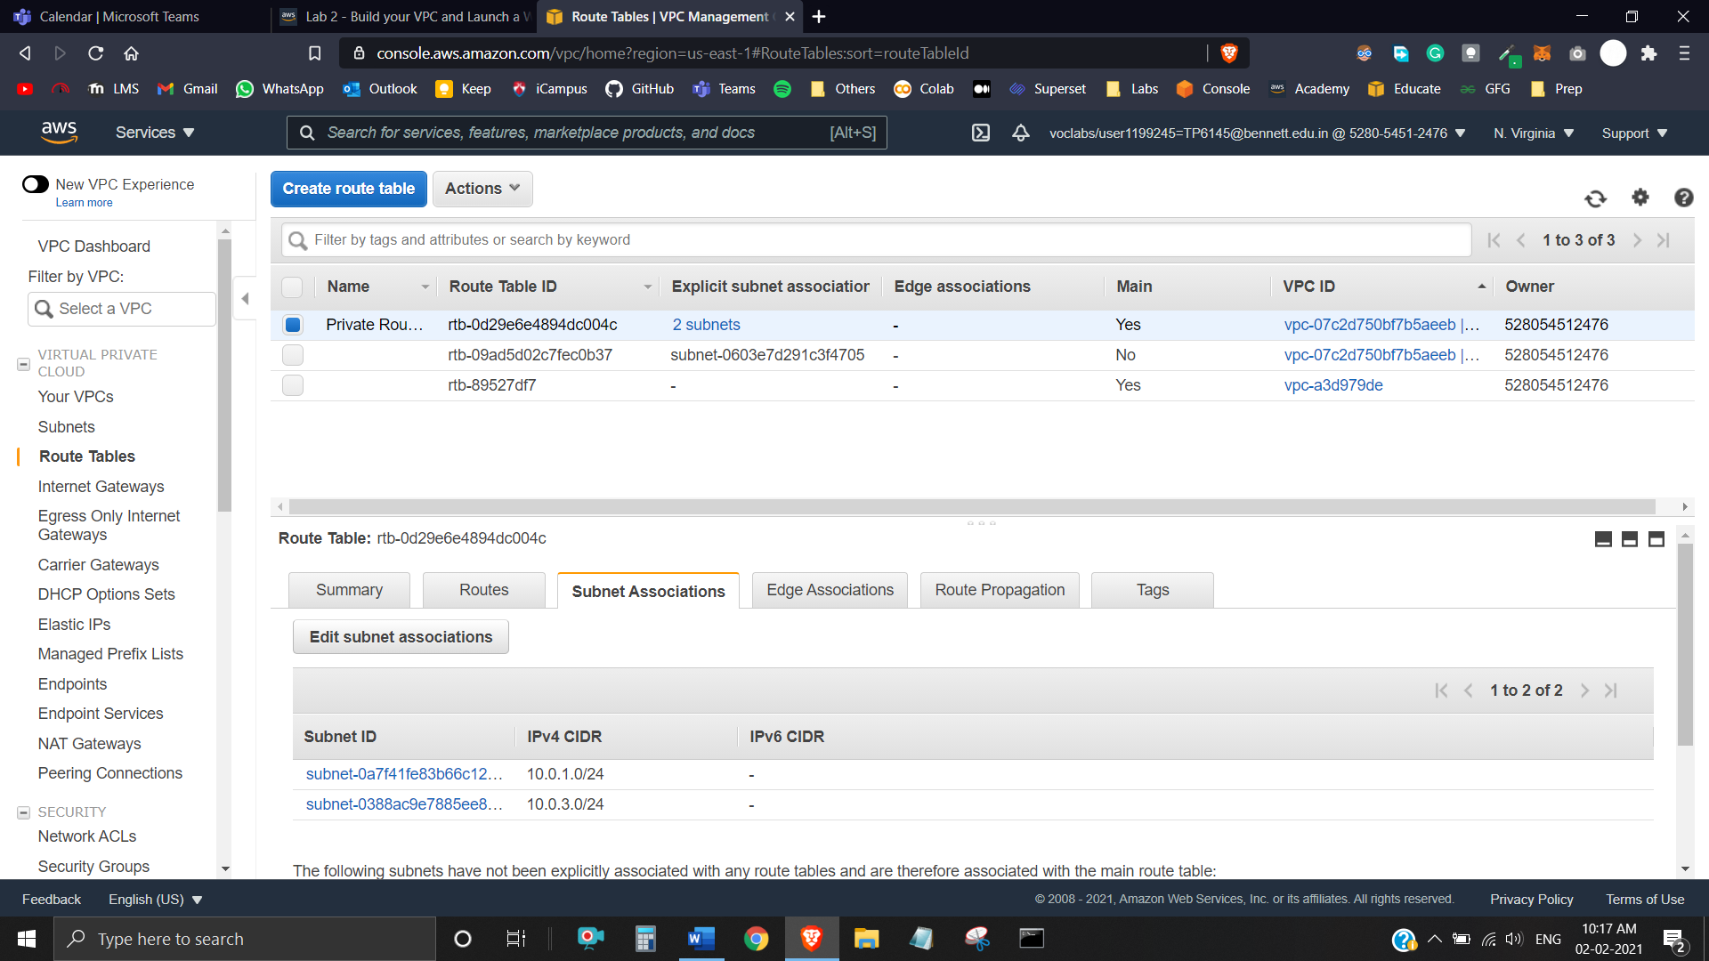

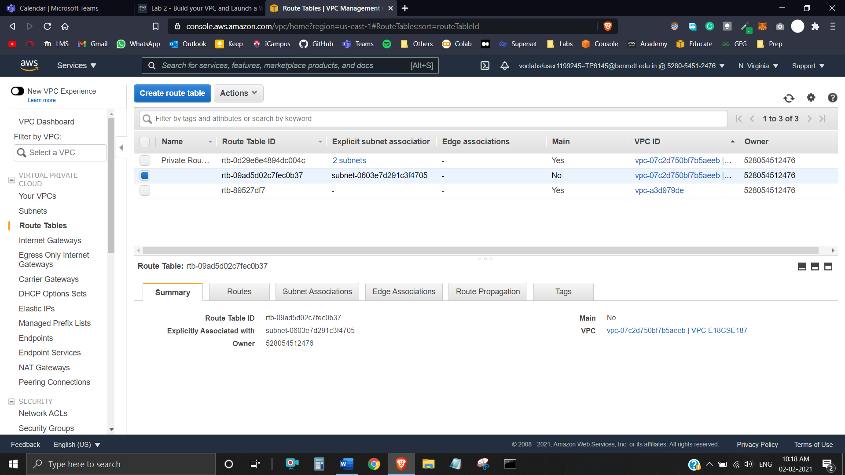

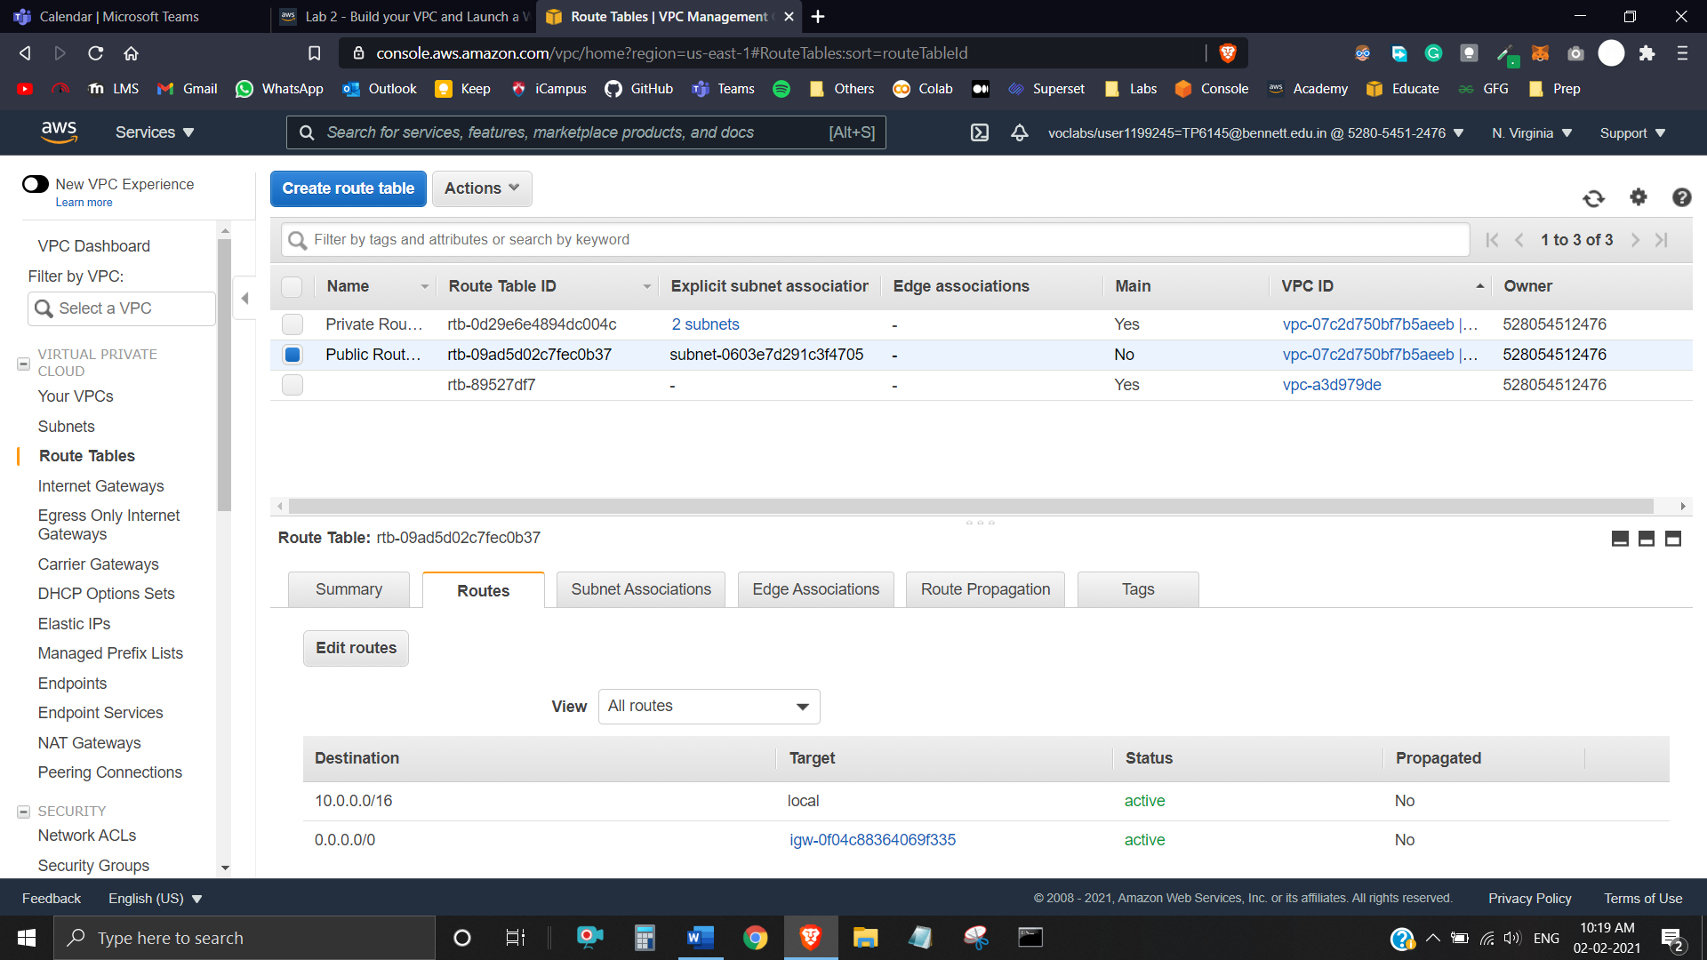

Note that **Destination 0.0.0.0/0** is set to **Target igw-xxxxxxxx**, which is the Internet Gateway. This means that internet-bound traffic will be sent straight to the internet via the Internet Gateway.

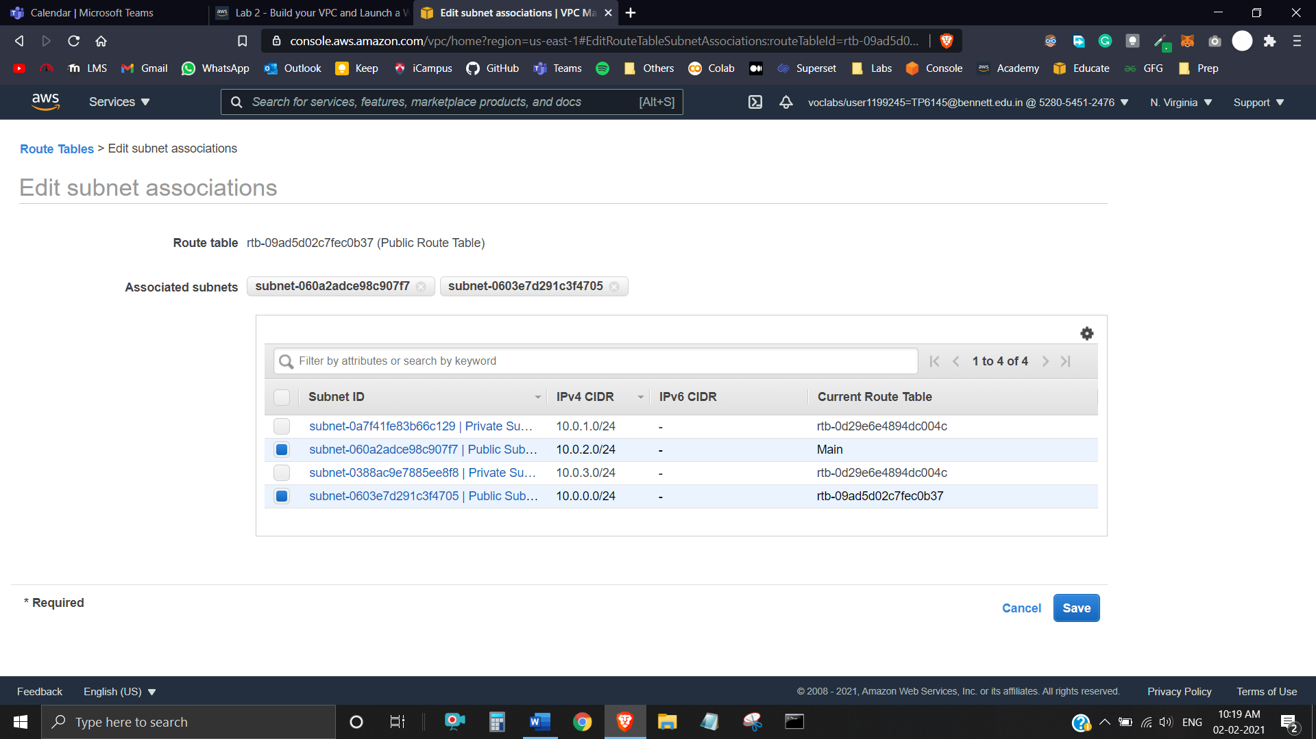

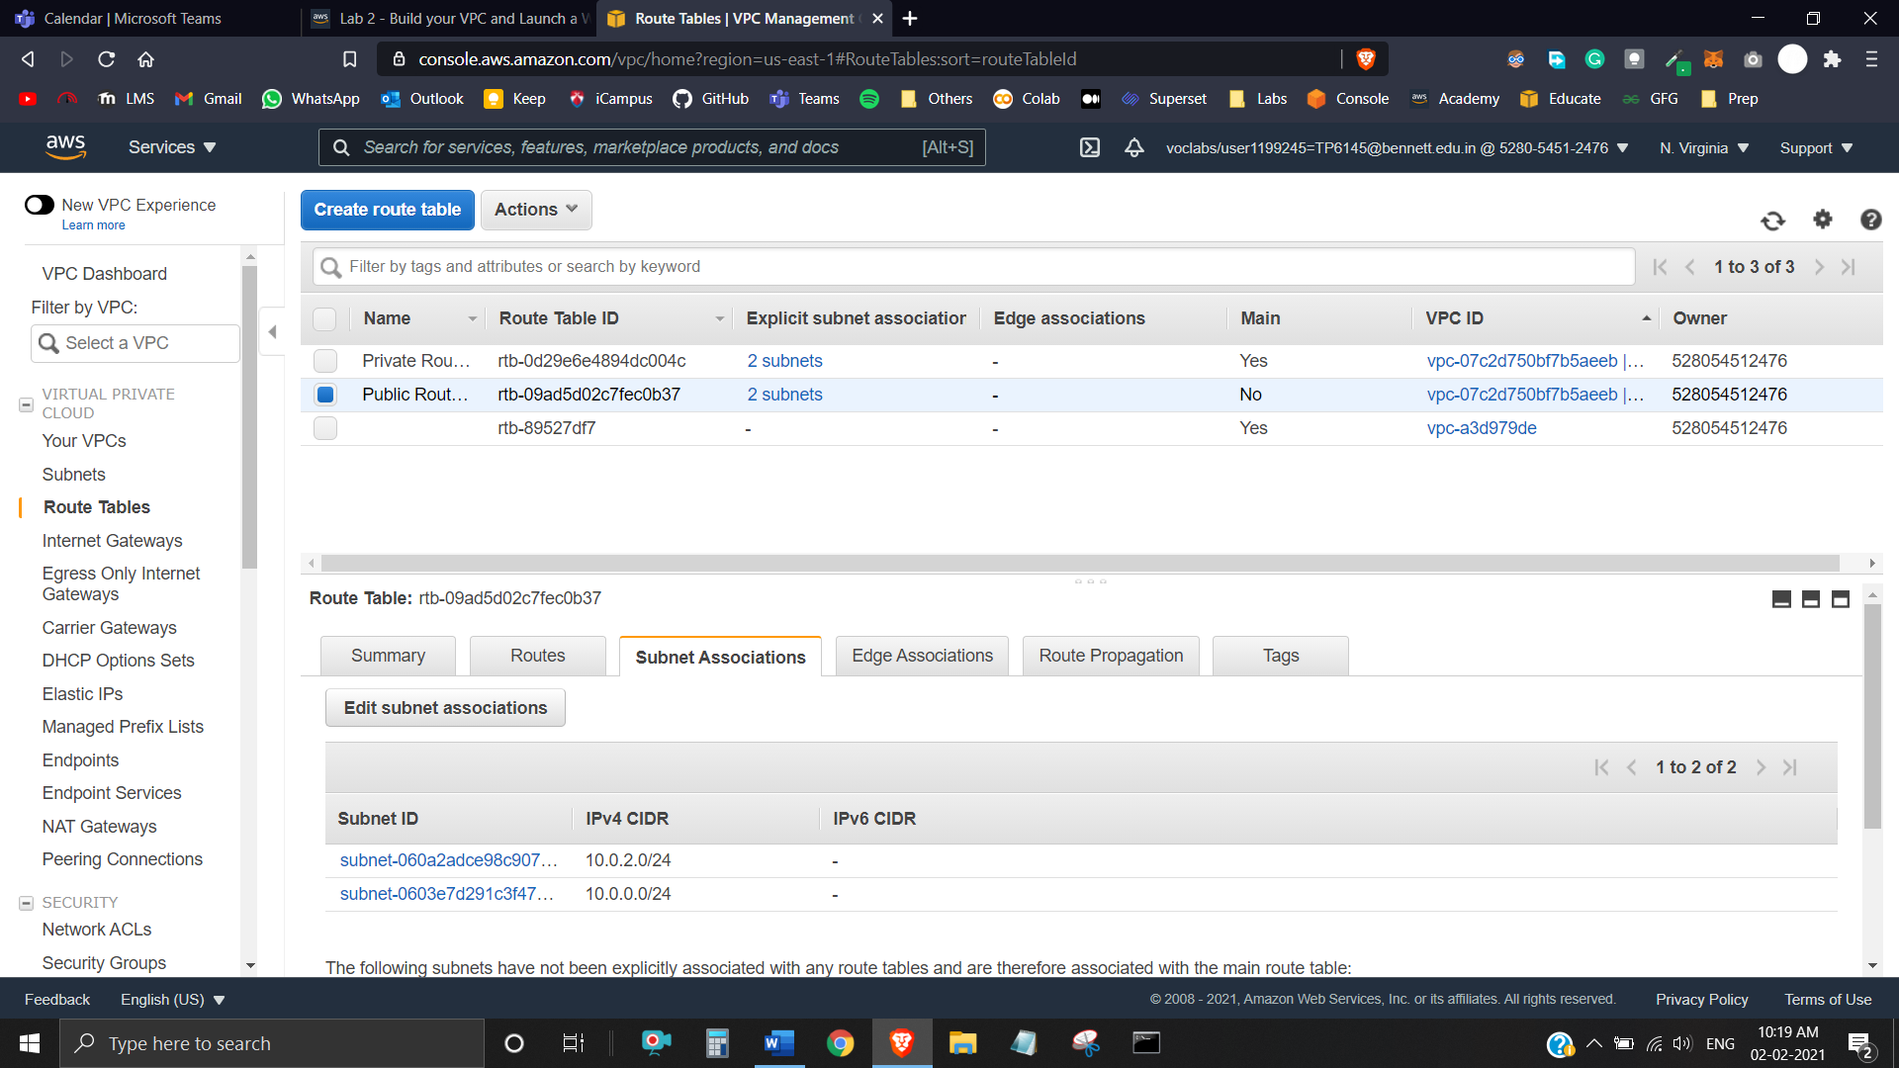

The VPC now has public and private subnets configured in two Availability Zones:

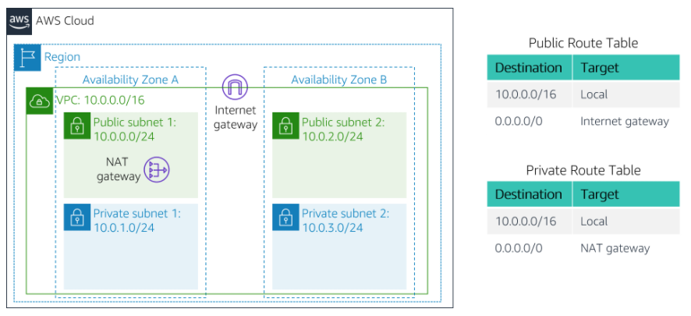

**Task 3:** Create a VPC Security Group

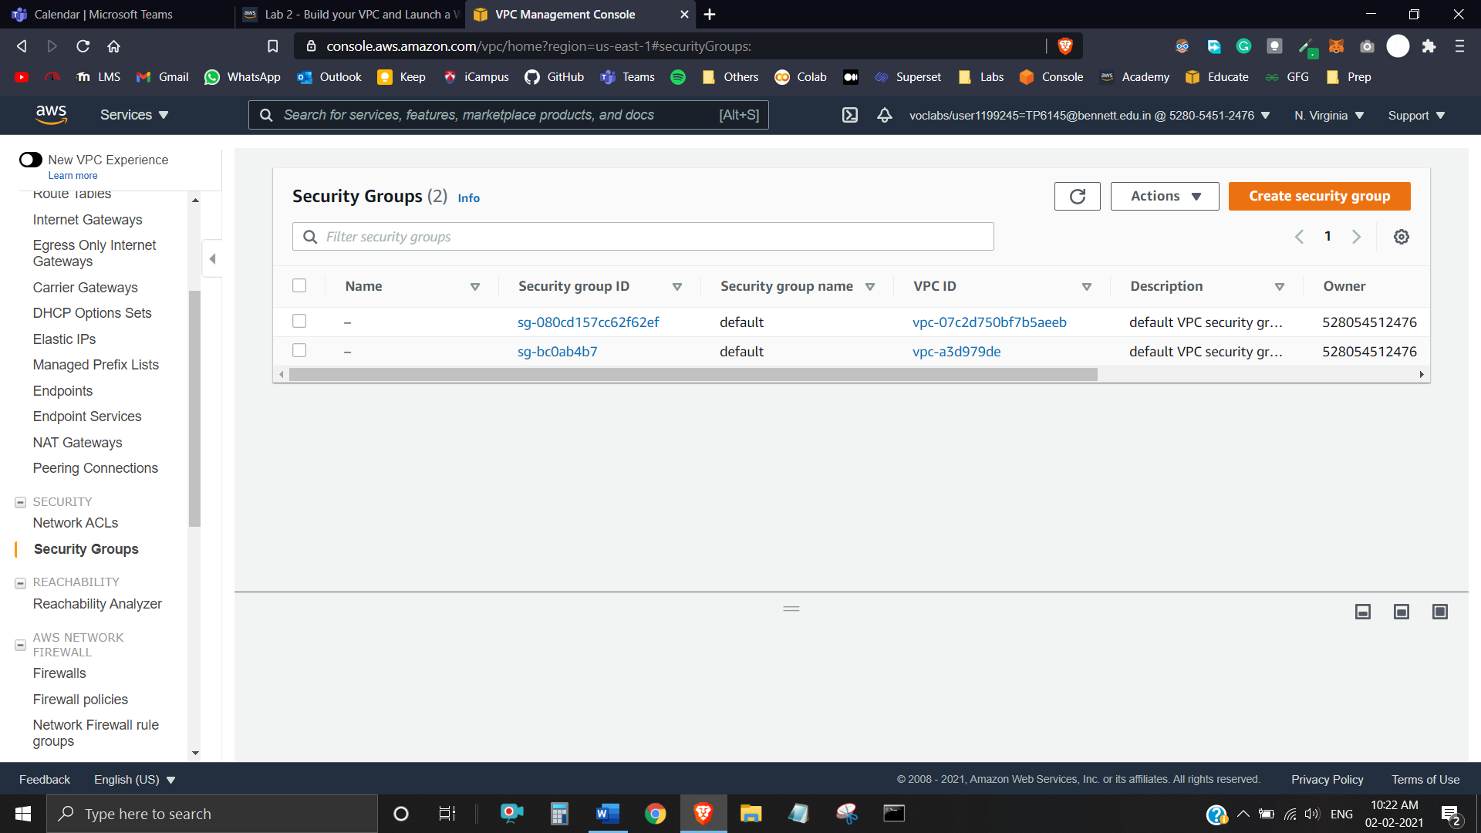

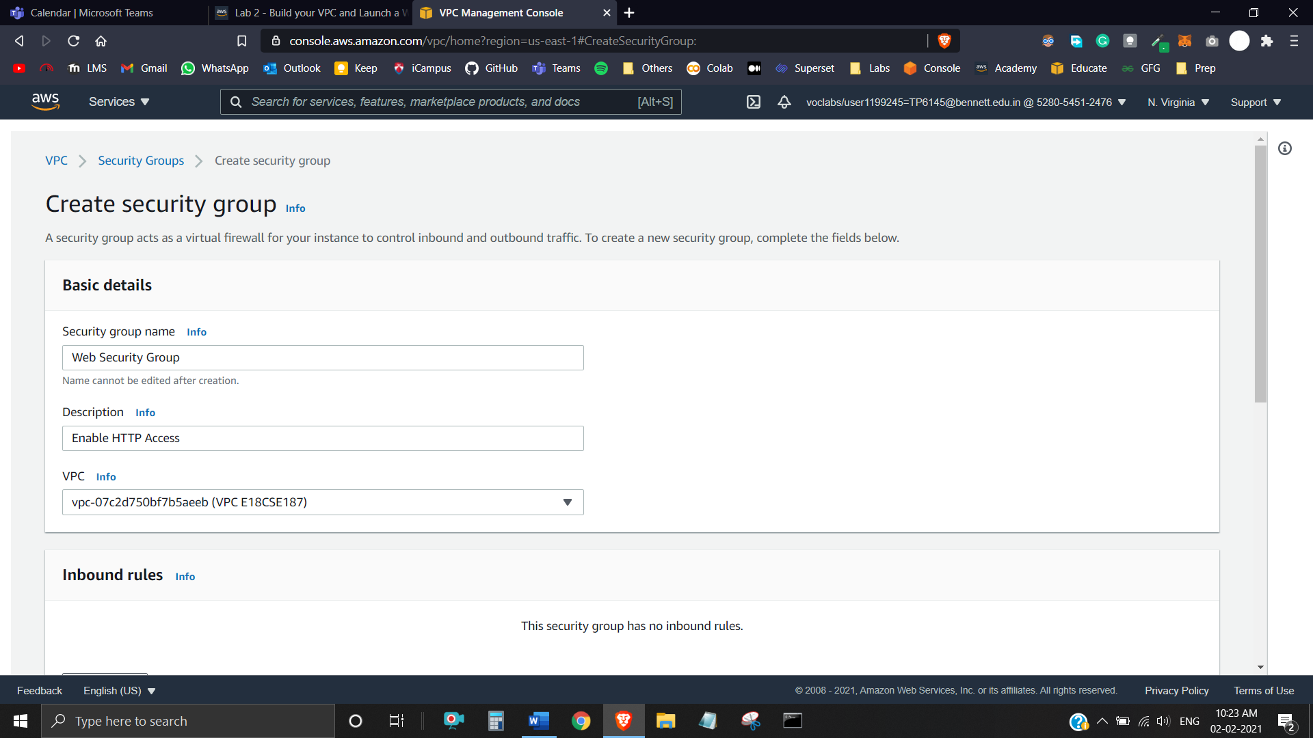

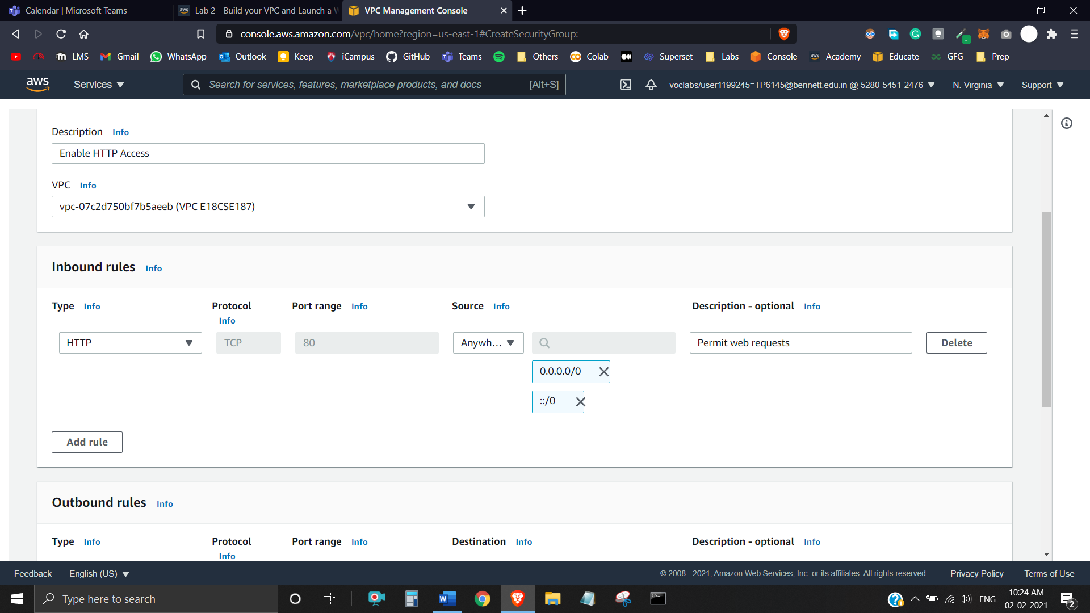

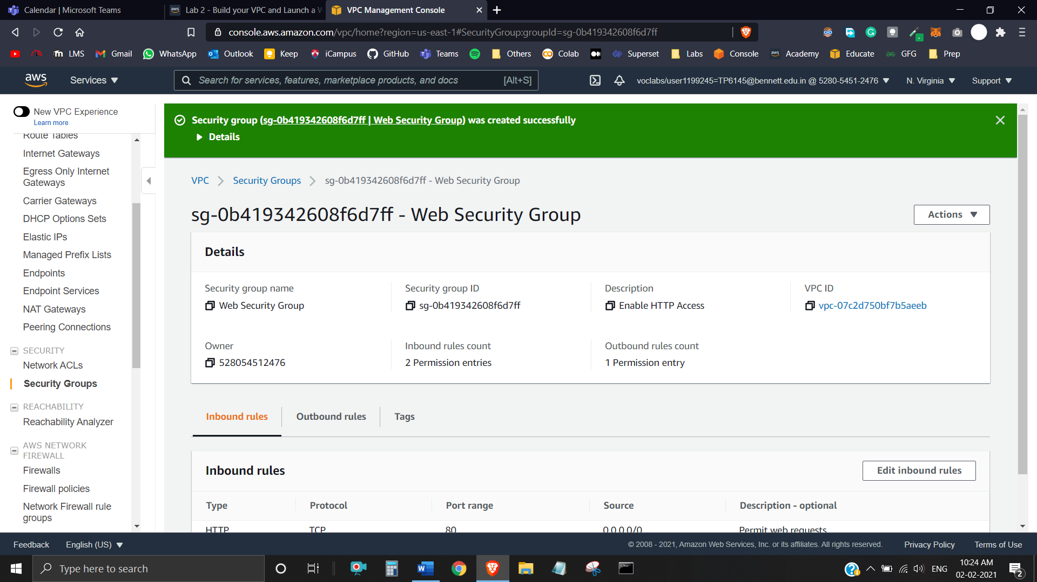

**Task 4:** Launch a Web Server Instance

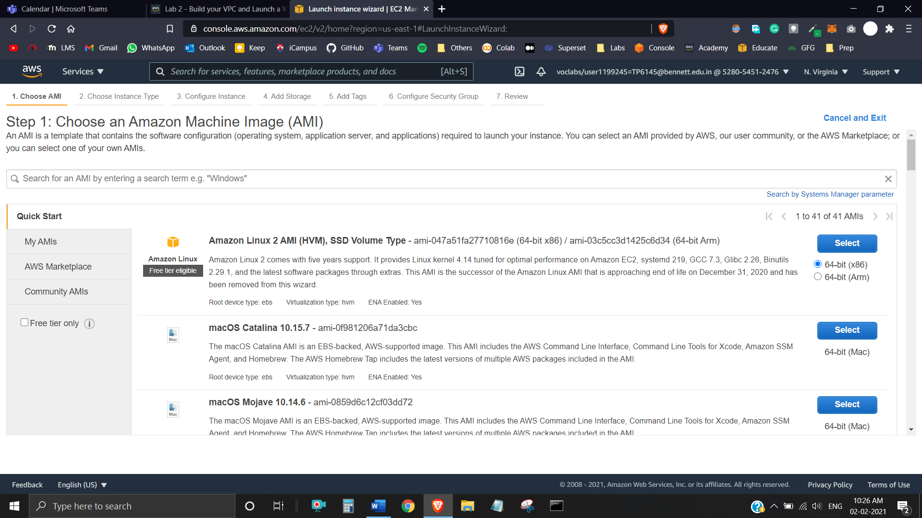

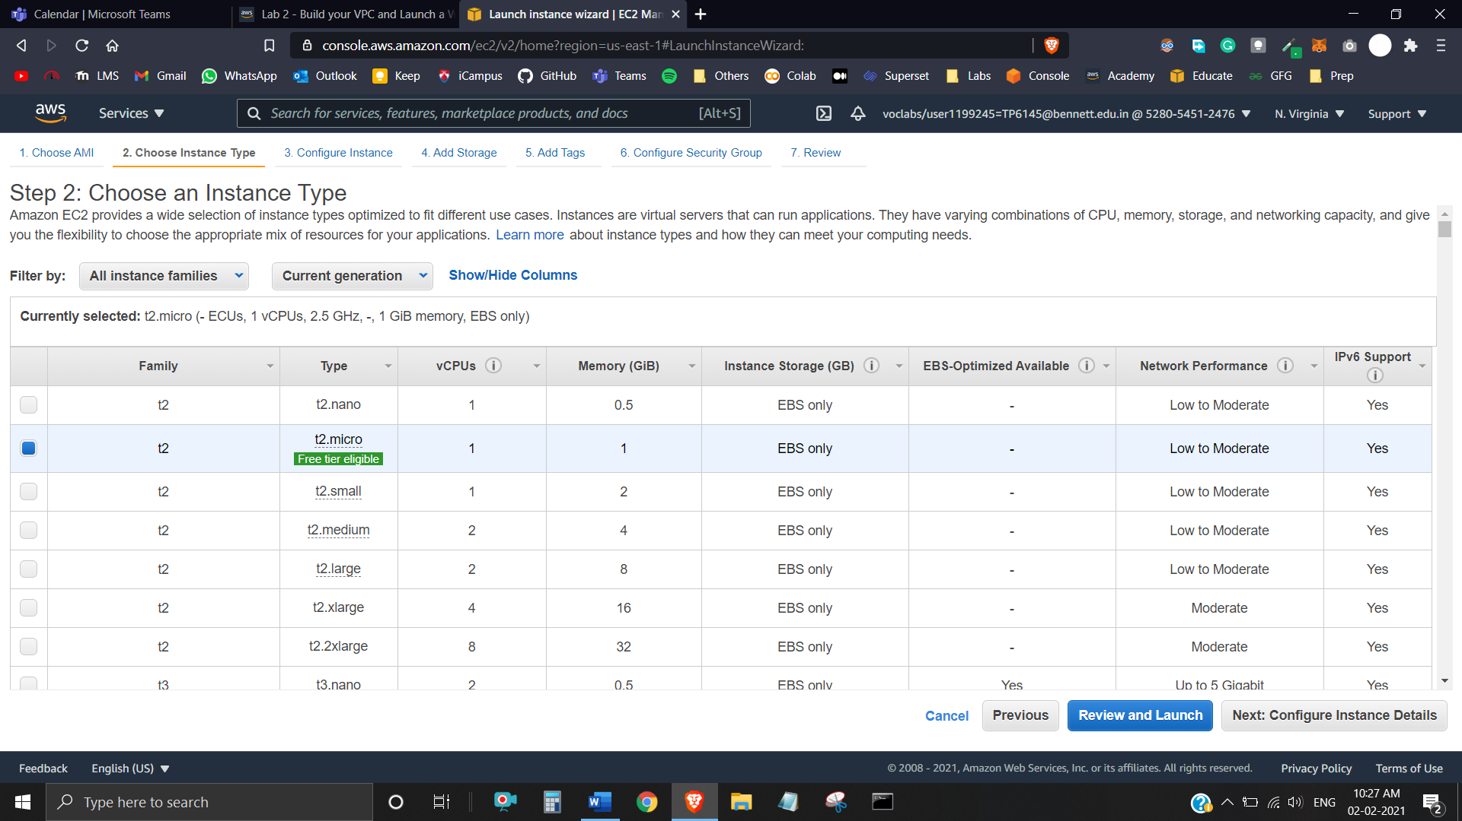

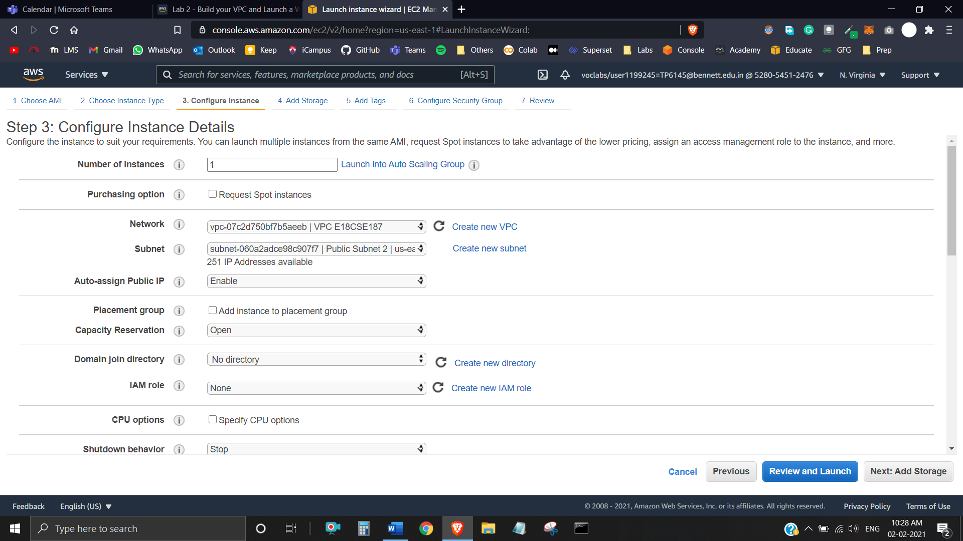

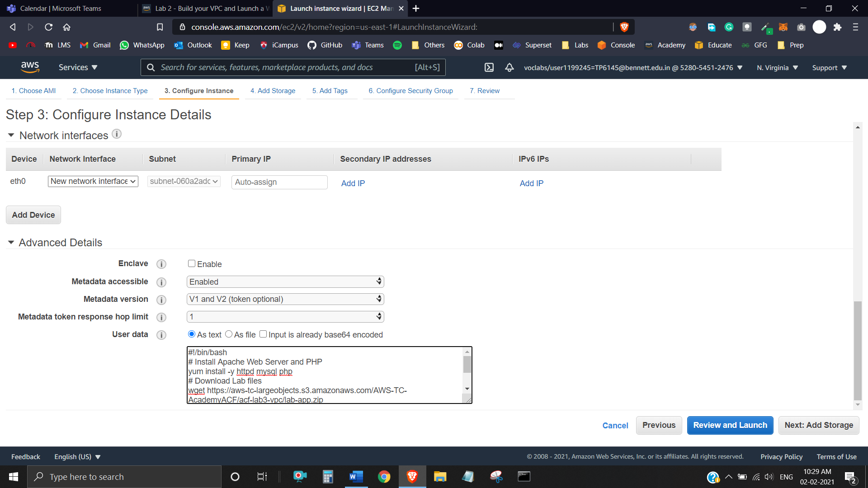

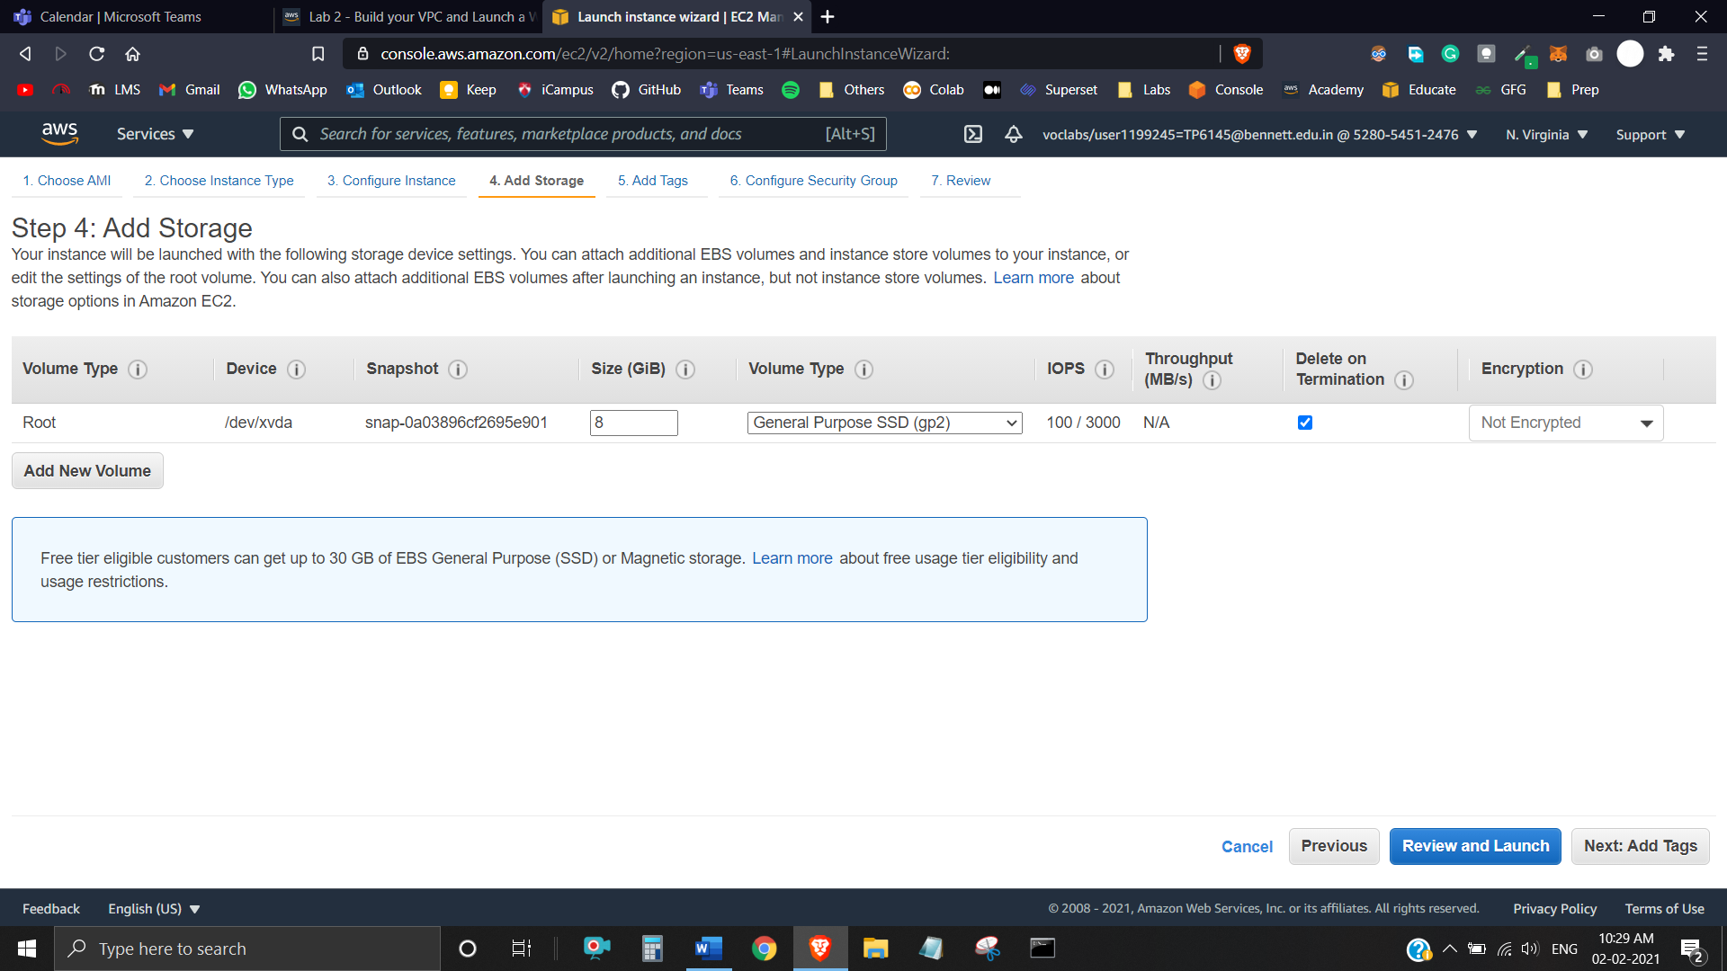

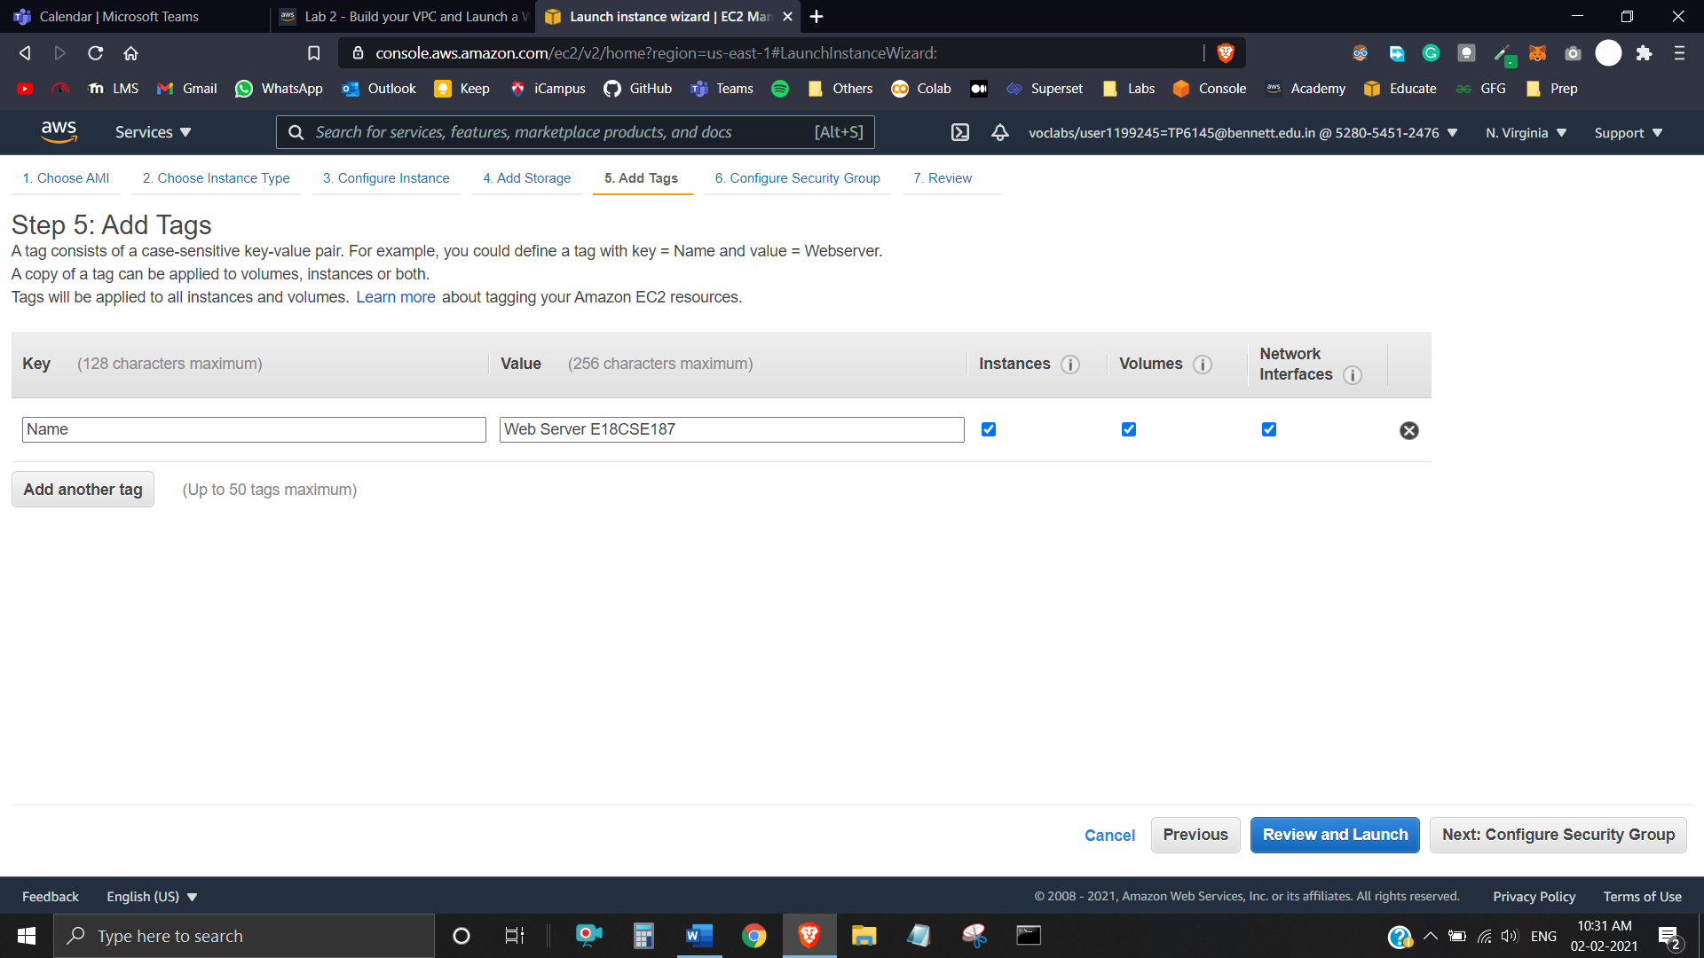

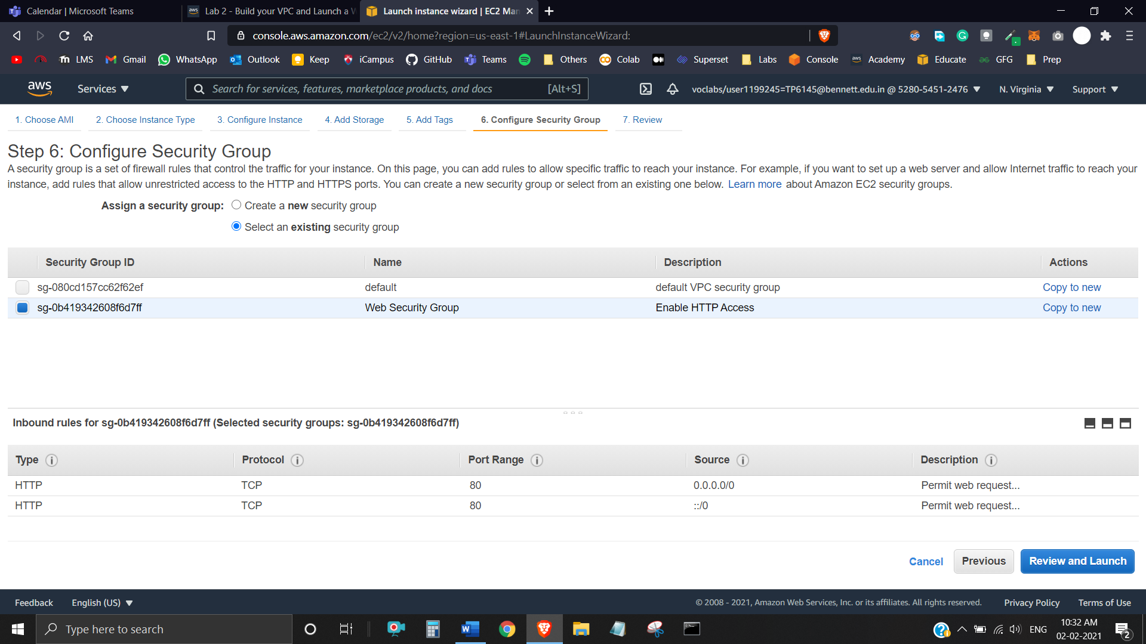

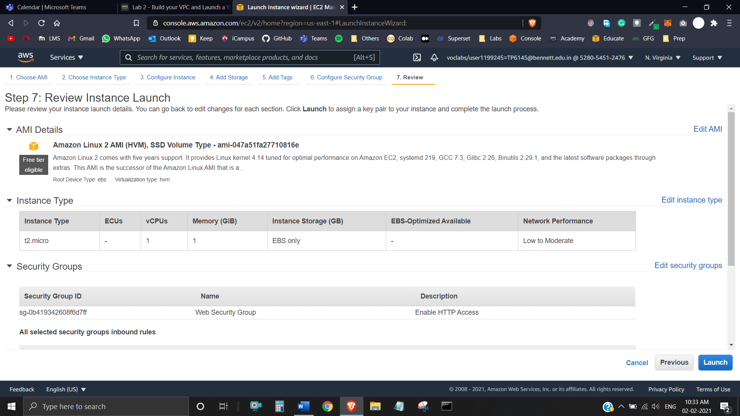

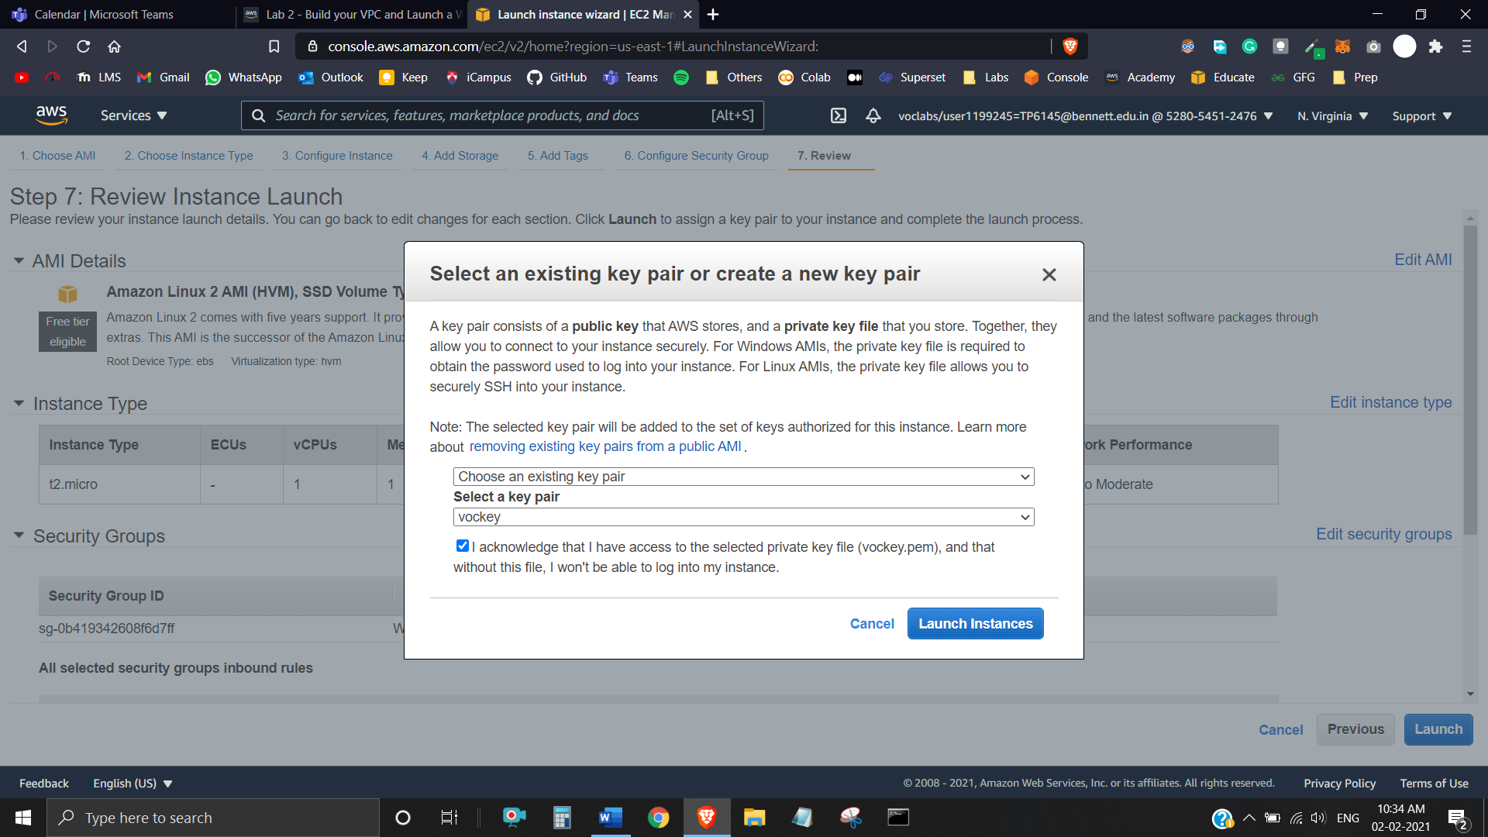

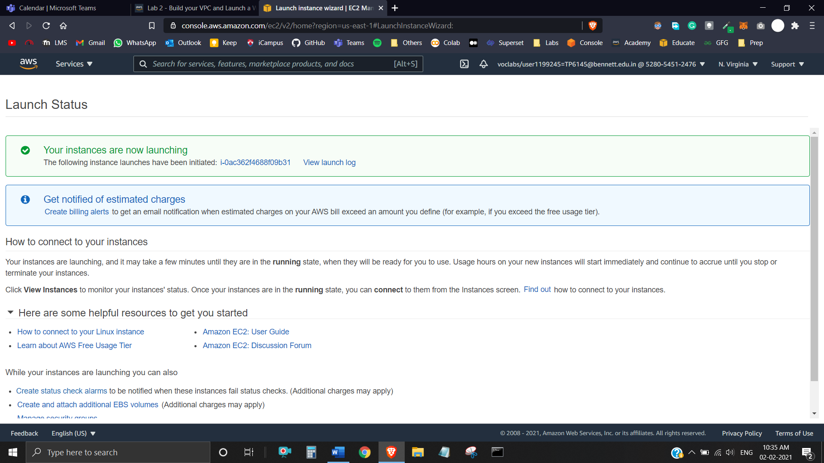

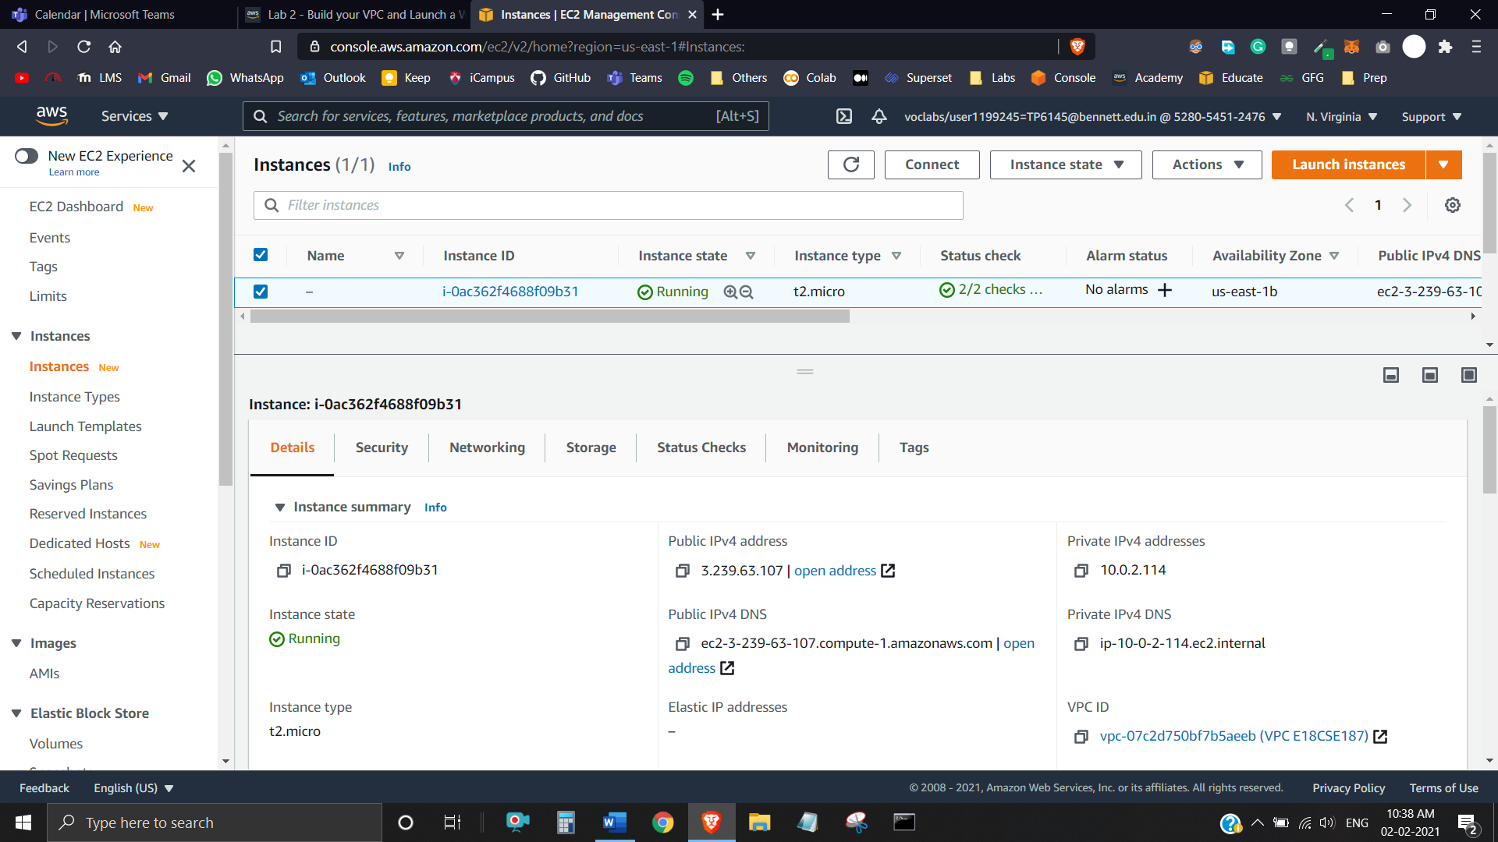

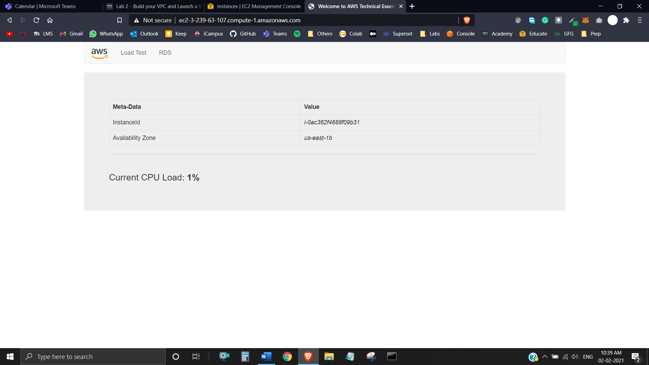

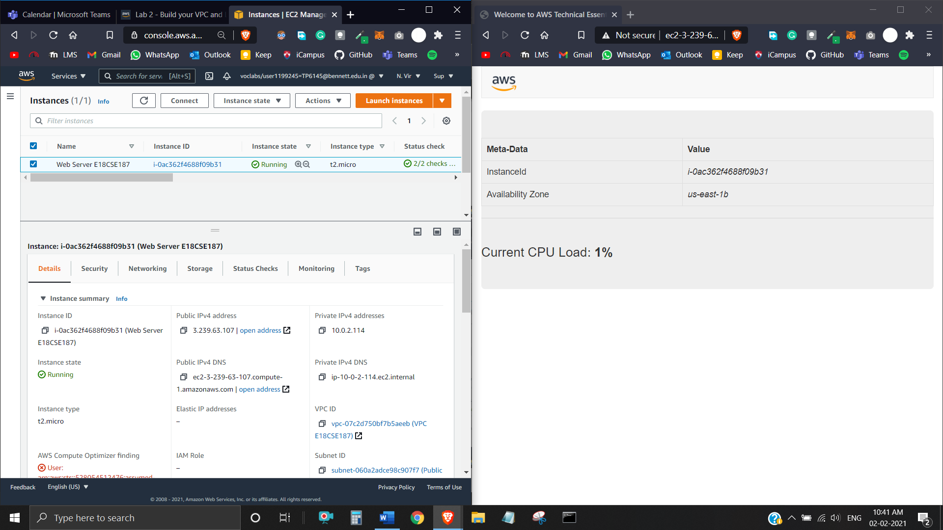

The complete architecture deployed is:

